Kyle Kodani

Homework 5

1a)

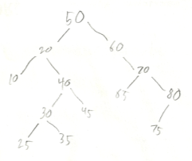

1b)

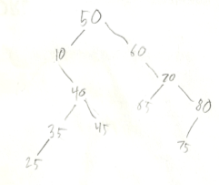

1c) inorder: 10, 20, 25, 30, 35, 40, 45, 50, 60, 65, 70, 75, 80

preorder: 50, 20, 10, 40, 30, 25, 35, 45, 60, 70, 65, 80, 75

postorder: 10, 25, 35, 30, 45, 40, 20, 65, 75, 80, 70, 60, 50

2a)

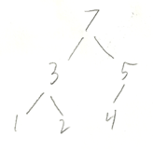

2b) 7 3 5 1 2 4

2c) 5 3 4 1 2

3a) struct Node

{

Node\* left;

Node\* right;

Node\* parent;

int data;

};

3b) insert()

if new value compared to current value is true

if left child of current node is NULL

make new node with new value and set it as current node’s left child. Make new node’s parent the current node

else (left child is another node)

call insert on left child node

else (new value compared to current value is false)

if right child of current node is NULL

make new node with new value and set it as current node’s right child. Make new node’s parent the current node

else (right child is another node)

call insert on right child node

4a) see next page

4a)

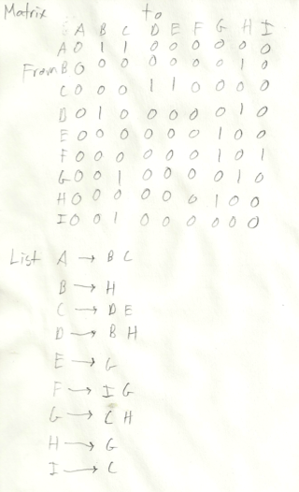

4b) E G C D B H

E G C D H B

E G H C D B